**t -Retail**



**HR ORBIT**

**Sonali Intellect Limited**

**, Bangladesh**

CONSOLIDATED DOCUMENT OF

PERFORMANCE APPRAISAL

**COPYRIGHT NOTICE**

**Copyright © 2024, Sonali Intellect Limited**

**All rights reserved.**

These materials are confidential and proprietary to Sonali Intellect Limited and no part of these materials should be reproduced, published, transmitted or distributed in any form or by any means, electronic, mechanical, photocopying, recording or otherwise, or stored in any information storage or retrieval system of any nature nor should the materials be disclosed to third parties without the prior express written authorization of Sonali Intellect.

**Revision History**

|  |  |  |  |  |  |
| --- | --- | --- | --- | --- | --- |
| **Version** | **Published Date** | **Description of changes** | **Author** | **Reviewed By** | **Approved By** |
| 1.0.0 | 09-08-2025 |  | Nafisa Ahmed Progga | Faiyaz Masrur |  |

**­­­**

**­­**

**TABLE OF CONTENTS**

1. INTRODUCTION 3

1.1 Purpose of the Document 4

1.2 Scope of the document 4

1.3 References 4

1.4 Terminology 5

1.4.1 Field Rule Properties 5

1.4.2 Field Type 6

1.4.3 Data Element 6

1.4.4 Acronyms & Abbreviations 7

2. Overview 8

3. Prerequisites 8

4. Business Requirement – Performance Appraisal 8

4.1 User Journey 9

A. Admin (HR) Journey 9

B. Employee Journey 9

C. Reporting Manager Journey 10

D. HR Journey 10

E. HOD, COO, and CEO Journey 11

4.2 List of Business Scenarios 11

5. Appraisal – Functions 12

5.1 User Authentication 12

5.2 Employee Repository: 12

5.3 Performance Appraisal Workflow: 12

5.4 Notifications: 13

6. SYSTEM INTERFACES & DATA FIELDS 13

6.1 Flowcharts & Diagrams: 13

6.1.1 Flow Chart 13

6.1.2 Activity Diagram 14

6.1.3 Data Flow Diagram (DFD) 15

6.1.4 Data Model and Schema Design 18

6.1.5 Class Diagram 20

6.1.6 Software Architecture Design 21

7. Conclusion 21

# 1. INTRODUCTION

## 1.1 Purpose of the Document[1]

This document specifies the functional and non-functional requirements for the HR Orbit Performance Appraisal System. The system is designed to automate and digitize the performance review process at Sonali Intellect Limited, replacing the current manual, paper-based workflow with a secure, web-based application.

The intended audiences for this document are:

1. Business Users.
2. Testers.
3. Technical Architects & Developers.

## 1.2 Scope of the document

The system manages the entire performance appraisal lifecycle, from employee self-appraisal to final approval by the CEO. It includes user management with role-based access, a centralized employee data repository, a multi-level appraisal workflow, and a real-time notification system. The system can also generate and download a final PDF of the completed appraisal form.

## 1.3 References

* Appraisal Form_HR Orbit_Developer__2025.docx
* Employee Supervisor Hierarchy.xlsx
* Meeting Summary_BRD_Draft_Performance Appraisal.pdf
* BRD_Performance Appraisal_HR Orbit.docx
* BPD_Performance Appraisal_HR Orbit.docx
* Scope Document_Performance Appraisal_HR Orbit.pdf
* Data Feild Parameter_Performance Appraisal_HR Orbit.pdf
* Flowchart_Performance_Appraisal.jpg
* Activity Diagram_Performance_Appraisal.jpg
* Context Diagram_Performance Appraisal.png
* Level -1 DFD_Performance Appraisal.png
* Level -2 DFD_Performance Appraisal.jpg
* Enhanched Entity Relationship Diagram ( EERD )_Performance Appraisal.png
* Schema Design_Performance Appraisal.png
* Class Diagram_Performance Appraisal.png
* Software Architecture Design_Performance Appraisal.png

## 1.4 Terminology

### 1.4.1 Field Rule Properties

This section lists down field type and field rule description

|  |  |
| --- | --- |
| **Code** | **Description** |
| R | Required |
| O | Optional |
| C | Conditional |
| CR | Conditionally Required |
| OOR | One of Fields Required |
| CE | Conditionally enabled (but not mandatory under that condition) |
| CD | Conditionally Disabled |
| H | Hidden |
| AP | Auto populated |
| CO | Conditional Optional (is optional under a condition else will not accept input) |
| CM | Conditional Mandatory (is mandatory under a condition else should not accept input) |
| NA | Not applicable |

### 1.4.2 Field Type

|  |  |
| --- | --- |
| **Code** | **Description** |
| F | Free format input (text box/text area) |
| P | Password |
| DD | Single select drop-down list of values |
| CB | Checkbox |
| RO | Read only |
| F | File upload |
| D | Date (provides a calendar for selecting) |
| T | Text (single line text input) |
| N | Number (numeric input) |
| TA | Textarea (multi-line text input) |
| AF | Already-filled (read-only, auto-populated) |

### 1.4.3 Data Element

|  |  |  |  |  |  |
| --- | --- | --- | --- | --- | --- |
| **Data Type** | **Description** | **Allowed Characters** | | | |
| AMT (XX, XX) |  |  |  |  |  |
| NUM/N (XX) | Number | 0 to 9 |  |  |  |
| AN | Alphanumeric | a to z | A to Z | 0 to 9 |  |
| AMT (XX, XX) | Amount | 0 to 9 | . | , |  |
| A | Alphabet | a to z | A to Z |  |  |
| DAT | Date (DD/MM/YYYY) | 0 to 9 | - | / |  |
| DATM | Date/Time (DD/MM/YYYY)  For time (HH:MM: SS AM/PM) | 0 to 9 | - | / | : |
| DATMZ | Date/Time with time zone | 0 to 9 | / | : | A to Z |
| TXT (XX) | Text | a to z A to Z 0 to 9 Space ! @ # $ % | ^ & * ( ) - _ + = | ` ~ | \ { } [ ] < | > ' ? " ; . , : / |

### 1.4.4 Acronyms & Abbreviations

|  |  |  |
| --- | --- | --- |
| **S N** | **Term** | **Explanation** |
| 1 | BRD | Business Requirements Document |
| 2 | BPD | Business Process Diagram |
| 3 | SRS | Software Requirements Specification |
| 4 | SDLC | Software Development Life Cycle |
| 5 | UI/UX | User Interface/User Experience |
| 6 | HOD | Head of Department |
| 7 | COO | Chief Operating Officer |
| 8 | CEO | Chief Executive Officer |
| 9 | PP | Pay Progression |
| 10 | API | Application Programming Interface |
| 11 | JWT | JSON Web Token |
| 12 | CORS | Cross-Origin Resource Sharing |
| 13 | POST | Power On Self Test |
| 14 | CSRF | Cross Site Request Forgery |
| 15 | REST | Representational State Transfer |
| 16 | ORM | Object Relational Mapping |

# 2. Overview

This document outlines the business requirements and functionality for the HR Orbit Performance Appraisal system. It details the user journeys, key features, data fields, and prerequisites for all stakeholders involved in the performance review process. The system is designed to digitize and automate the entire workflow, from self-appraisal to final approval, providing a single source of truth for all project-related information.

# 3. Prerequisites

* The system's development must follow a defined SDLC process. The technical stack includes **React** for the front-end, **Django** for the back-end, and **PostgreSQL** as the database. The system must also be compatible with all major modern web browsers.
* Only existing employees who have been authorized to use the Performance Appraisal can use this functionality.

# 4. Business Requirement – Performance Appraisal

## 4.1 User Journey

This section provides a detailed, step-by-step guide for each user role, outlining their interactions with the HR Orbit system.

### A. Admin (HR) Journey

This guide outlines how an Admin uses the system for initial setup and management.

* **Step 1: Login**
* Navigate to the HR Orbit login page.
* Enter your **Username** and **Password**.
* **Step 2: Access the Admin Panel**
* From the dashboard, locate and click the "Admin Panel" link. This panel is exclusive to this role.
* **Step 3: Create a New Employee**
* Select the "Create Employee" option.
* Fill in all mandatory data fields: **Employee ID, Name, Designation, Department, Joining Date, Grade, Salary, Reporting Manager,** and **Password**.
* **Step 4: Set Appraisal Hierarchy**
* For each new employee, define their specific appraisal hierarchy. This sets the sequence for all future review and approval steps (e.g., Employee -> Reporting Manager -> HR -> HOD -> COO -> CEO).
* **Step 5: Manage Organizational Data**
* Use the Admin Panel to manage and update master data like departments, designations, and grades as needed.
* **Step 6: Download Documents**
* Once an appraisal cycle is complete, you can download the final, signed-off appraisal form as a PDF document for your records.

### B. Employee Journey

This guide outlines how an employee completes their annual self-appraisal.

* **Step 1: Login**
* Log in to the HR Orbit system using the credentials provided by your HR Admin.
* **Step 2: View Dashboard**
* The dashboard will display employee’s personal profile and the Performance Appraisal form.
* **Step 3: Update Profile Information**
* Click on the profile to edit specific fields such as **Responsibilities, Previous Work Experience, Educational Qualifications,** and **Professional Certificates**,  can also upload signature and a profile picture. The system will automatically calculate the total work experience.
* **Step 4: Fill Out Employee Self Appraisal Form**
* Click to open the performance appraisal form, which is auto-generated for the current year.
* Complete the self-appraisal section, detailing your **achievements, goal completion,** and proposed **training and development plan**.
* **Step 5: Submit the Form**
* Once submitted, the form becomes read-only for the employee, and a notification is sent to your Reporting Manager.
* **Step 6: View Final Results**
* After the entire review process is complete and the CEO has approved the form, the employee can log in to view the final, completed form and all reviewer remarks.

### C. Reporting Manager Journey

This guide outlines how a manager reviews and provides feedback on their direct report's performance.

* **Step 1: Receive Notification**
* Reporting Manager will receive an notification when one of his/her direct reports submits their appraisal form.
* **Step 2: Access the Review Form**
* Log in to the dashboard. The right-hand panel will display a list of pending review forms for the supervisees.
* Click on the relevant form to open it.
* **Step 3: Provide Feedback**
* Review the employee's self-appraisal. Reporting Manager can only edit the sections designated for this role.
* Provide comments on the employee's **achievements, goals,** and **training plans**.
* Provide an **overall assessment** and **remarks** on the employee's performance and potential.
* **Step 4: Submit the Form**
* Click the "Submit" button. The form will then be sent to the HR department for the next stage of review, and an email notification will be sent.

### D. HR Journey

This guide outlines the steps for the HR role in validating and finalizing the review.

* **Step 1: Receive Notification**
* HR will receive an email notification when a form is submitted for hr review.
* **Step 2: Access the Review Form**
* Log in and access the review form from the dashboard. The form will be pre-filled by both the employee and their Reporting Manager. The system will also automatically populate data for **total leave taken** and **late attendance**.
* **Step 3: Input Salary Data**
* Enter the employee's **basic salary**. The system will automatically calculate the **gross salary** and **increment** based on this input.
* **Step 4: Make Recommendations**
* Use the **decision table** on the form to make recommendations for promotion or increment.
* **Step 5: Submit the Form**
* Submit the form to send it to the next reviewer in the hierarchy (e.g., the HOD).

### E. HOD, COO, and CEO Journey

This guide outlines the final steps for senior management in the approval process.

* **Step 1: Receive Notification**
* Each reviewer receives an notification when the form is submitted to them.
* **Step 2: Review the Form**
* Log in and open the form. Reviewer can view all previous sections and remarks from the employee, manager, and HR.
* **Step 3: Finalize Decision**
* Reviewer can only add their own comments and use the **decision table** to make final decisions on promotion and increment.
* **Step 4: Approve**
* The CEO's final approval marks the completion of the appraisal process.

## 4.2 List of Business Scenarios

The system's functionality includes:

* **User Login:** A secure login page with fields for username and password. User credentials are provided by the Admin.
* **Forgot Password:** A functionality that allows users to reset their password via a link sent to their email.
* **Admin Panel:** A restricted view for HR to manage all administrative tasks.
* **Dashboard:** A role-based view that acts as the user's primary workspace.
* **Notifications:** The system sends real-time email and in-app notifications for pending reviews and deadlines.
* **Employee Profile:** A view that displays all employee repository information and allows the employee to edit specific fields.
* **Change Password:** An option for authenticated users to change their password.

# 5. Appraisal – Functions

## 5.1 User Authentication

The system authenticates users with a username (email) and password. Sessions are token-based and will auto-logout inactive users after 15 minutes for security.

# 5.2 Employee Repository:

The Admin panel is a central repository for all employee data. The Admin can create accounts with details such as Employee ID, Name, Department, Designation, and Reporting Manager. Employees can edit their profile information, including past work experience, educational qualifications, and professional certificates.

# 5.3 Performance Appraisal Workflow:

The system follows a sequential, multi-level workflow. The form progresses from the Employee to the Manager, then to HR, HOD, COO, and finally to the CEO for approval. Each reviewer can only edit their designated section, ensuring data integrity and accountability.

## 5.4 Notifications:

The system sends automated notifications to the next reviewer when a form is submitted. Reminders are sent one week before the submission due date, and access to the form is locked once the deadline has passed.

# 6. SYSTEM INTERFACES & DATA FIELDS

## 6.1 Flowcharts & Diagrams:

**Disclaimer:** *The screen layouts provided in the document are solely for depicting the functionality of the application. The actual look and feel of the application may vary according to the branding, theme and data field definitions specific to the implementation.*

*Document will contain product screenshot and the Data Definition Section for each screen will specify the gaps like removed field, new fields, or field label text change.*

___________________________________________________________________________

The following diagrams provide a visual representation of the system's architecture, data flows, processes, and database structure.

### 6.1.1 Flow Chart

The **Flowchart** illustrates the sequential steps in the performance appraisal process, from the initial form submission by the employee to the final approval by the CEO.

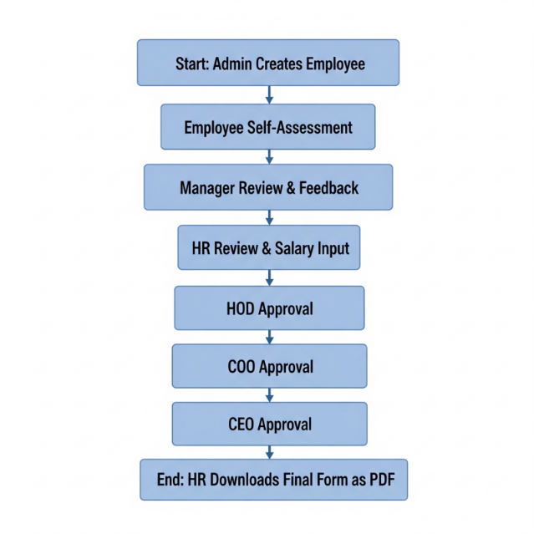

### 6.1.2 Activity Diagram

The activity diagram models the sequential and parallel workflows within the HR Orbit Performance Appraisal System. It visually represents the dynamic behavior of the system, illustrating the flow of control from one activity to another. This diagram highlights the steps, actions, and decisions involved in the entire appraisal process, from the initial login and form submission by an **Employee** to the final approval by the **CEO**.

It details how the appraisal form progresses through the various hierarchical levels - including **Manager**, **HR**, **HOD**, and **COO**—and shows the conditional logic (e.g., promotion recommendations) and parallel activities that occur at each stage. The diagram provides a clear, step-by-step visualization of the business process, ensuring all stakeholders have a shared understanding of the system’s operational flow.

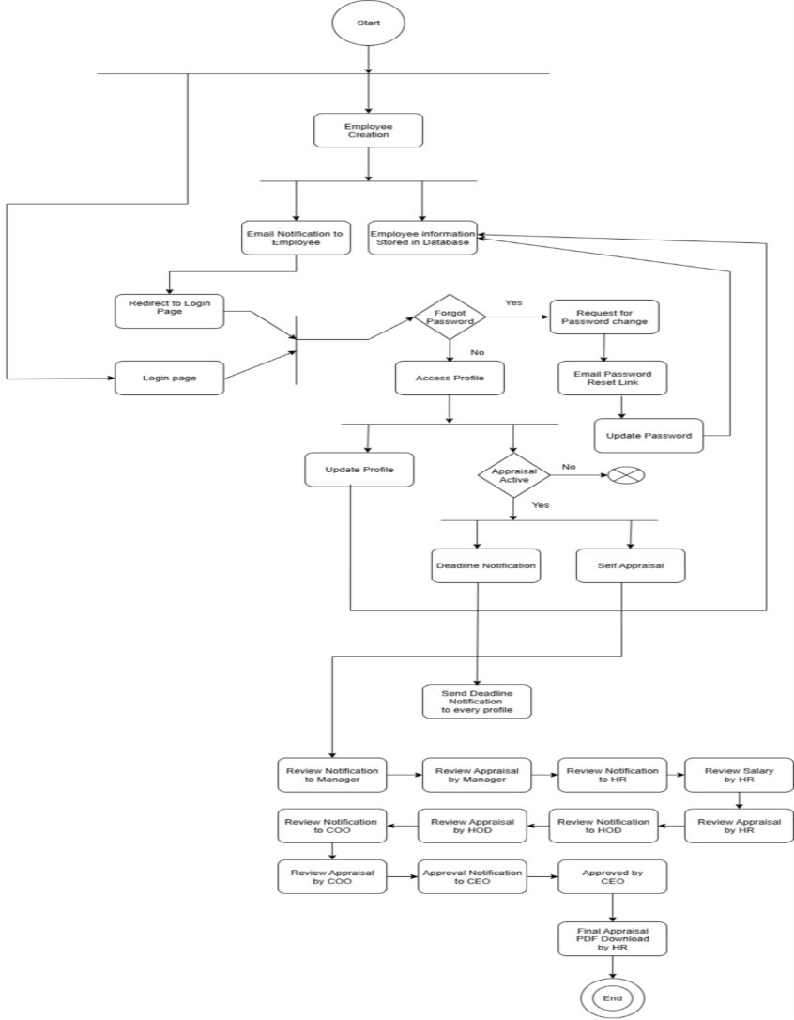

### 6.1.3 Data Flow Diagram (DFD)

#### 6.1.3.1 Context Diagram/ Level-0 Data Flow Diagram (DFD)

The **Context Diagram** (a Level-0 DFD) shows the entire Performance Appraisal System as a single process, highlighting the flow of information between the system and external entities such as the Employee, Manager, HR, HOD, COO and CEO.

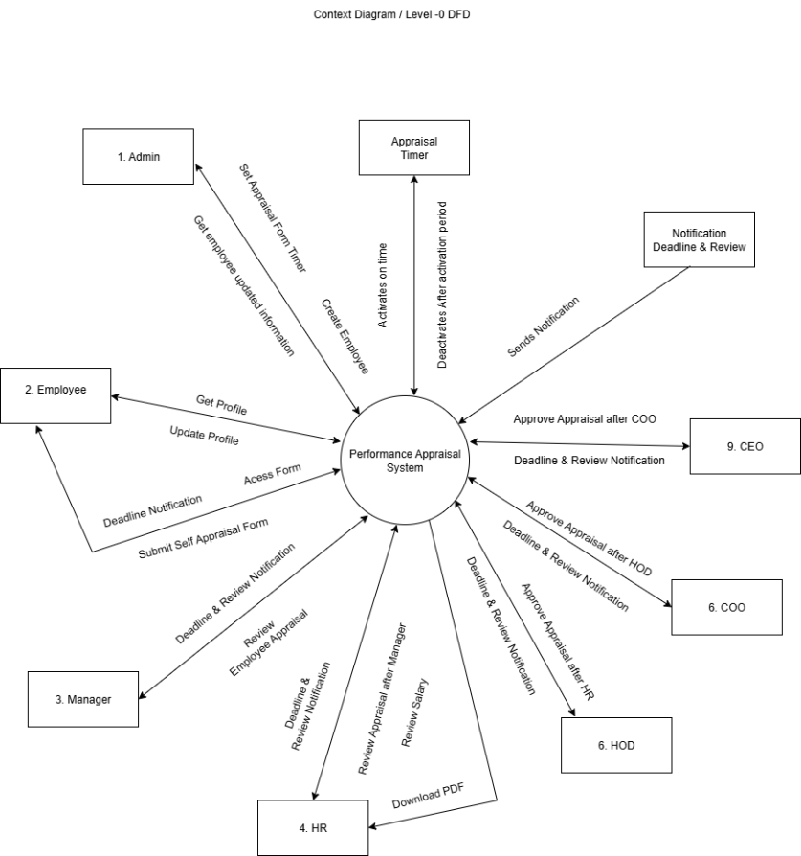

#### 6.1.3.2 Level-1 Data Flow Diagram (DFD)

The **Level-1 DFD** breaks down the system into its primary processes, including Employee Repository Management, the Appraisal Workflow, and the Notification system.

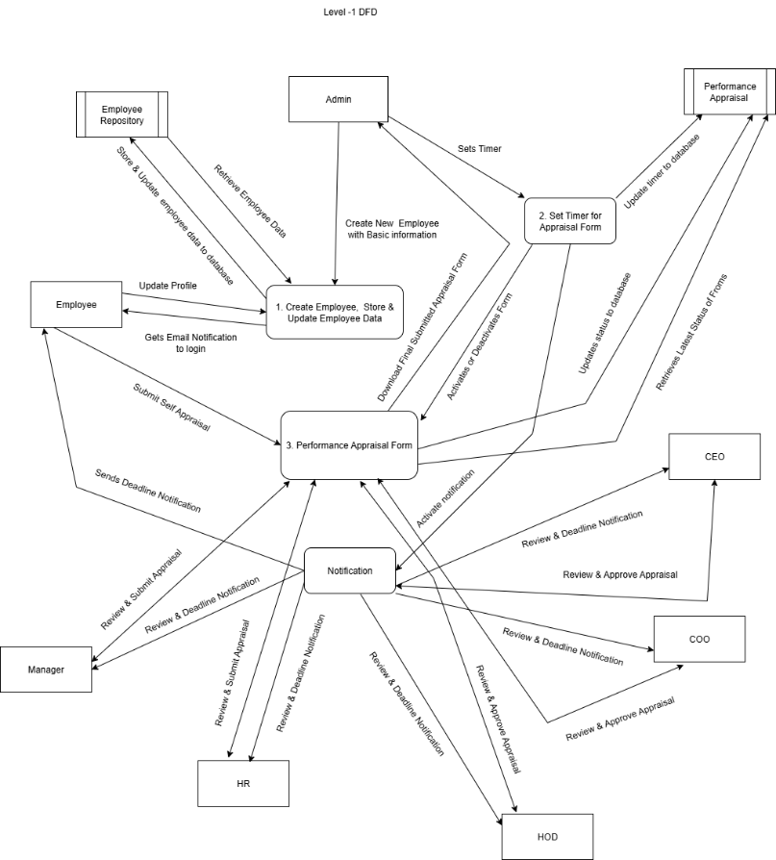

#### 6.1.3.3 Level-2 Data Flow Diagram (DFD)

The **Level-2 DFD** provides a more detailed view of specific processes, such as the appraisal workflow, showing the data stores and sub-processes involved.

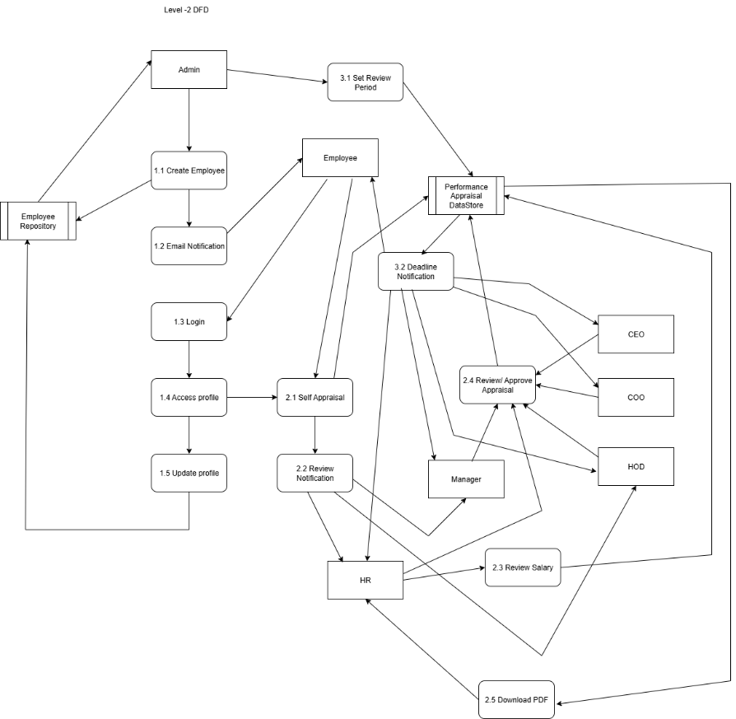

### 6.1.4 Data Model and Schema Design

#### 6.1.4.1 Enhanced Entity Relationship Diagram (EERD)

The **Enhanced Entity Relationship Diagram (EERD)** visually represents the data entities, their attributes, and the relationships between them. This includes entities like User, Employee, AppraisalForm, and DecisionTable.

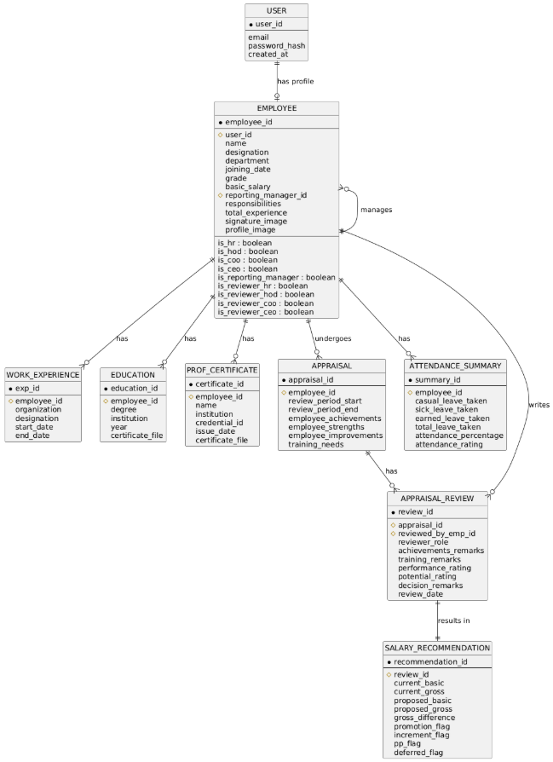

#### 6.1.4.2 Schema

**Schema Design** provides the logical database structure, detailing the tables, fields, and their data types, as derived from the EERD.

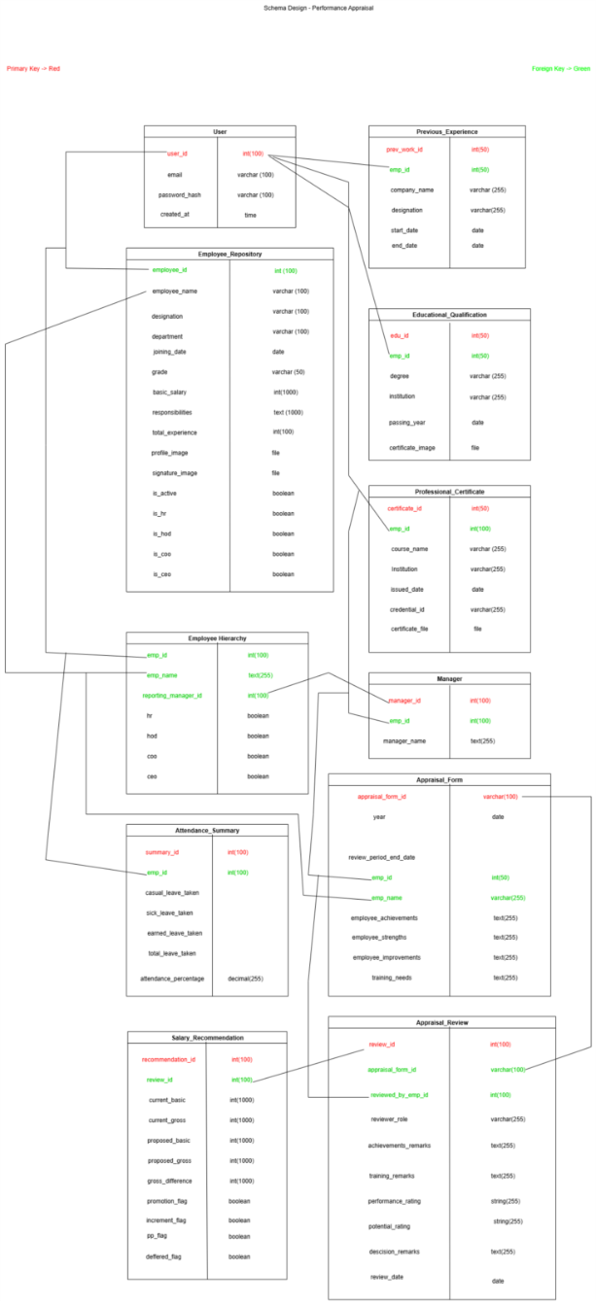

### 6.1.5 Class Diagram

The **Class Diagram** presents the static structure of the system by showing the classes, their attributes, methods, and the relationships (like inheritance, association, and aggregation) between them. It outlines the blueprints for the software components.

### 6.1.6 Software Architecture Design

The **Software Architecture Design** diagram provides a high-level overview of the system's structure. It outlines the system components, the relationships between them, and the principles that guide its design, showing how different modules (e.g., frontend, backend, database) interact.

# 7. Conclusion

The automated performance appraisal system will streamline the current manual process, providing a more efficient, transparent, and accurate workflow. By implementing this system, Sonali Intellect Limited can improve the overall employee performance management experience, ensure timely reviews, and maintain a comprehensive and accurate record of all appraisal activities.

1.